Campus Tree Care Plan

Table of Contents

- Purpose
- Campus Tree Advisory Committee
- Campus Tree Care Policies
- Protection and Preservation
- Goals and Targets
- Tree Damage Assessment
- Prohibited Practices
- Definitions and Terminology
- Communication Strategy

DePaul University Lincoln park campus and street tree inventory
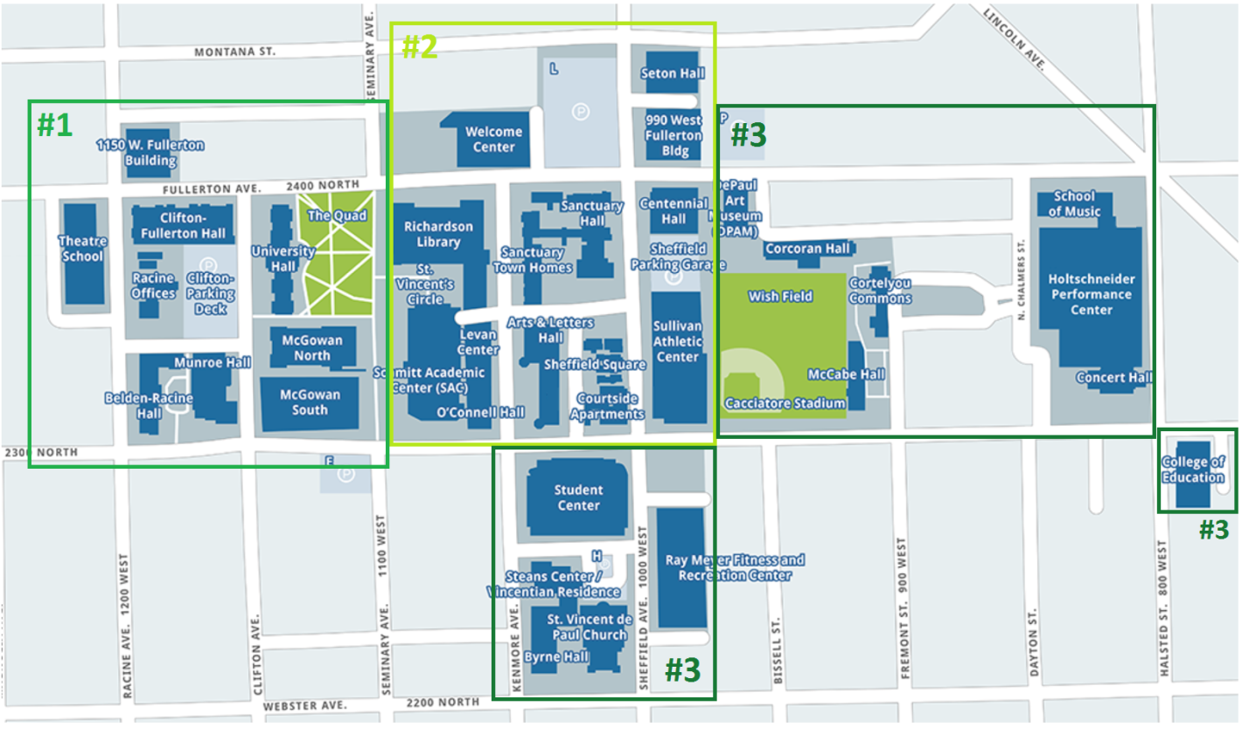

Area #1
Campus trees – 126
Street trees – 60

Area #2
Campus trees – 144
Street trees – 77

Area #3
Campus trees – 84
Street trees – 62

Total Campus and Street Trees: 553

Purpose

The purpose of Depaul University’s campus tree care plan:
- Develop policies that establish DePaul University’s commitment to best practices in tree planting, protection, maintenance, and management of campus trees.
- Protect and maintain the urban forest during campus development and construction.
- Provide guidelines for the removal of dead, dying, and hazardous trees.

Campus Tree Advisory Committee
The Campus Tree Advisory Committee assists in providing guidance and planning, approval of a comprehensive campus tree plan, the education of the campus population, and the development of connectivity to the community.

The Campus Tree Advisory Committee is composed of:
- Eric Fredericks, Grounds Foreman
- Dr. Jess Vogt, Assistant Professor
- Al De Reu, Openland’s TreeKeepers Program Manager
- Kaitlyn Pike, M.S. Environmental Science
- Allison Preble, M.S. Environmental Science
- Thomas Ebeling, M.S. Environmental Science

Campus tree care policies

tree selection:
As per City of Chicago Municipal Code 10-32-030(g), the Bureau of Forestry has the authority to prohibit and regulate the planting of certain varieties of trees, shrubs, and other plant material.
To achieve desired diversity, the City encourages the use of the Systematic Diversity concept that espouses the planting of trees in alternating groups of different species down a city street or along a lot frontage. Where feasible, no tree species should represent more than 20-25% of the block segment. Boundaries of these groups may be defined by: spacing between light poles, existing trees, and building or lot size.
Newly planted campus and street trees are determined by the current Grounds Foreman and Campus Tree Advisory Committee member, Eric Fredericks, who follows the most recent Chicago Urban Tree Planting List, as well as the practice of ‘right tree, right place’. Examples of preferred species by location found below.

Recommended tree species list:

Grass Parkways
- Bloodgood London planetree
- Columbia London planetree
- Bur oak
- Swamp white oak
- Hackberry

Landscape Islands
- Northern catalpa
- Chicago-blues black locust
- Hybrid Elms
  - Accolade elm
  - Commendation elm
  - Pioneer elm
  - Triumph elm
- Chicagoland hackberry

Tree “Pits”
- Hybrid elms
  - Accolade elm
  - Commendation elm
  - Pioneer elm
  - Triumph elm
- Ginkgo
  - Princeton sentry ginkgo
  - Magyar ginkgo
- Skyline honeylocust
- Chicagoland hackberry
- Chanticleer pear
- Kentucky coffeetree

Under Powerlines
- Hedge maple
- Japanese tree lilac
- Amur maple
- Redspire pear

Tree planting:
All tree plantings should follow the role of ‘right tree, right place,’ as to limit the likelihood of future conflict. During planting, planting holes should be no deeper than the root flare, and 1.5 to 2 times the diameter of the root ball. Soil within the site should be tampered as to limit settling, and any burlap or wire baskets should be removed from the top 1/3 of the root ball. Examine root system for potential girdling roots. For containerized trees, bare root and balled and burlap trees; remove or straighten encircling roots in a radial form. If the root collar flare is buried, remove excess soil and plant so the root flare is slightly exposed above ground. Soil may be amended, but fertilizer is not necessary. 2 to 3 inches of mulch may be applied in a donut shape around the base of the tree, ensuring that the root flare is still visible. Newly planted trees shall receive 10 gallons of water for every DBH, once a week, for two growing seasons.

Landscaping:

Pruning
A portion of the landscaping budget shall go towards the maintenance of campus trees, including ongoing pruning schedules to ensure that the overall health and aesthetic value of campus trees are maintained.

Removal
Any hazardous trees, with either a defect or risk of injury or damage to persons or property, are to be replaced with a new tree, as to maintain the campus’ current canopy percentage. In recent years, most trees requested for removal have been standing dead ash, making way for many newly planted, native species.

Catastrophic events
DePaul classifies an “emergency” as any situation creating imminent danger to: lives, health, or safety; public and private property; or the ability of the University to reasonably carry on normal operations. In the event of a downed tree or limb through a weather-related or similar event, the Director of Lincoln Park Facility Operations will coordinate all facility evacuations, closure, cleaning, repair, and restoration on campus, as well as the coordination of supplies and management of contracted labor and the relocation of affected units.

Protection and Preservation

Tree protection zones
All trees within a construction area shall be enclosed with fencing as to protect their critical root zones (CRZ). The International Society of Arboriculture defines CRZ as an area equal to a 1-foot radius from the base of the tree’s trunk for each 1 inch of DBH. This means that a tree with a DBH of 15 inches should be protected by a 15-foot radius tree protection zone (TPZ). This is to decrease the likelihood of damage to the trunk from large equipment, as well as damage to the CRZ from soil compaction and trenching (root severance). Storing of materials or heavy equipment is prohibited within designated TPZ. Under certain circumstances, disturbing or cutting roots in a CRZ may be unavoidable. In such cases, the work should be done only under the on-site supervision of an ISA Certified Arborist.

Replacement trees
If trees have been removed, damaged, or killed, before, during, or after construction, a replacement tree of equal or greater value shall be planted.

Goals and targets

Campus wide inventory
A thorough inventory of DePaul’s campus should be updated by Dr. Jess Vogt’s ENV 341 class, Urban Forests as Social-Ecological Systems. If this is not possible, the DePaul Student Tree Committee can help to fill this role.

Increase diversity
From an inventory conducted by Dr. Jess Vogt’s ENV 341 class, we found that DePaul’s current urban forest lacks a healthy diversity of species, with a large percentage of the population represented by honey locust (26.5%). In order to increase the sustainability of DePaul’s urban forest, it is recommended that the University continues to plant a diversity of tree species so that no one species represents over 20% of the overall population.

tree damage assessment

enforcement, penalties, and appeals
The facility operations representative of the Campus Tree Advisory Committee is responsible for the enforcement of all Campus Tree Care Policies, with penalties and appeals under their discretion.

Prohibited practices

Tree planting and removal
The Campus Tree Advisory Committee’s faculty advisor and student representatives shall be informed of all tree plantings and removals, so that the current campus tree inventory can be updated accordingly.

Definitions and terminology

campus trees
Trees residing on DePaul University’s Lincoln Park campus property.

canopy cover
The percent of a fixed area covered by the crown of an individual plant species. Canopy cover is used to express the relative importance of individual species within a vegetation community and as a measure of land cover change or trend.

Critical root zone
The International Society of Arboriculture defines CRZ as an area equal to a 1-foot radius from the base of the tree’s trunk for each 1 inch of DBH. Cutting or disturbing a large percentage of a tree’s roots increases the likelihood of the tree’s failure or death. Never cut tree roots that are more than four inches wide; roots that large are usually structural. Cutting them can destroy the stability of the tree, causing it to fall over.

Diameter at breast height (DBH)
The diameter or width of the main stem of a tree as measured 4.5 ft. above the natural grade at its base.

Diversity
Diversity is measured through a combination of species richness (the number of species present) and species evenness (the abundance of each species).

girdling roots
A root that grows around the trunk of the tree, restricting and cutting off the flow of water and nutrients, oftentimes leading to premature death. Prevention begins at planting, where encircling roots should be redirected or pruned and the trunk flare made visible.

invasive species
Any kind of living organism that is not native to an ecosystem and causes harm to the environment, the economy, or human health.

inventory
The gathering of accurate information on the health and diversity of a community forest. An inventory should, at the very least, include a tree’s location, genus and species, DBH, and condition.

native tree
Native plants are plants indigenous to a given area in geologic time. This includes plants that have developed, occur naturally, or existed for many years in an area.

root flare
Part of the tree that thickens and emerges at the surface level of the soil, where the trunk meets the underground the root system. It is very important that the root flare is visible when planting trees, as to avoid premature death.

Street trees
Trees residing adjacent to University property, but that are owned and maintained by the City property. Regardless, these trees are still apart of the campus environment, and are included in inventory collection and monitoring.

tree protection zone
The area surrounding a preserved or planted tree that is essential to the tree’s health and survival, and is protected within the guidelines of these regulations.

communication strategy

DePaul Trees - student tree committee
The DePaul Student Tree Committee is the leading voice in advocating for trees’ on campus, as well as supporting outside action in support of Chicago’s urban forest as a whole. DSTC does this through hosting Service Learning volunteer days, an Arbor Day observance day during Earth Week, and other student-run events and field trips. The President of DSTC is responsible for maintaining the University's standing as a Tree Campus, USA by the Arbor Day Foundation.

